

18 May 2022

**Terra Industrial New Zealand Ltd**

PO Box 16 168

16 Branston Street, Hornby

Christchurch 8441, New Zealand

03 983 2333 Tel

www.TerraCat.co.nz

**Atlas upload of all warehouses to Naxt worker**

**You will need:**

* Atlas installed – add yourself to the below AD group

* Atlas license

1. Connect to the Atlas server: CCLAXATLPRD
2. Open Atlas Management Studio

Eventually, Atlas should show up in Software Centre to install

* Logged into the Atlas application (you need to do this before opening the following spreadsheet)

1. First, click on the settings wheel, check the host name, needs to be CCLAXATLPRD

Once the above has been checked, you can log into Atlas

Make sure both data services are green (only if you are wanting to test in Sandbox first otherwise having only production in green is fine for this task)

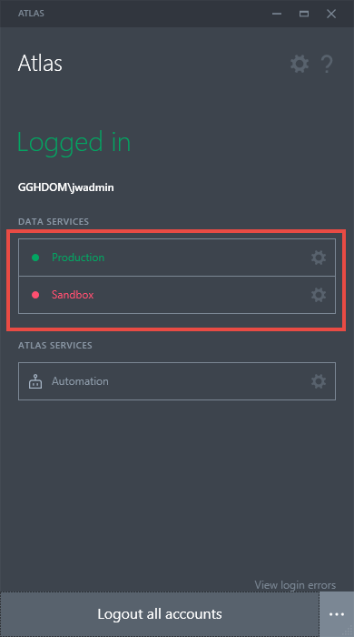

* Atlas Worker Warehouse Template (You can find the excel spreadsheet template here <https://itsdterracat.zendesk.com/hc/en-nz/articles/6308156496915-Atlas-upload-of-warehouses-to-Naxt-worker>) – called “Atlas Template Warehouse Worker Upload”
* A new separate excel spreadsheet

Once you have all the above, you can continue with the following steps 😊

First, you will need to **Enable Editing**

Next, check the data source in the Atlas template, so the upload goes to the right environment.

If you want to practice first, make sure the data source is directed at Sandbox

Here is how to check:

Atlas tab at the top > Tools > Manage data sources

If you do not need to practice, then change the dropdown box to **Production** then click **Replace**

For your new spreadsheet, probably best to save it somewhere first before continuing

1. Make sure you are on the **Worker Warehouse Report** tab at the bottom
   1. Click **Refresh** at the top on the **Atlas** tab

1. Filter for the user’s employee ID that is connected to the worker in NAXT

1. Highlight all their warehouses > right click > copy (or click CTRL C on your keyboard)

1. In your new separate spreadsheet > right click > paste (or CTRL V on your keyboard)

1. Now go to the **All Warehouses** tab in the Atlas upload template
   1. Highlight all the warehouses
   2. Right click > copy (or CTRL C)

1. Go back to your new separate spreadsheet
   1. Right click > paste (CTRL V)
   2. Name the first column something like “warehouses the worker has”
   3. Name the second column something like warehouses the worker needs”
   4. Should look something like below

1. So that we don’t end up uploading the ones the worker already has, lets get rid of those duplicates.
2. Remaining in your new separate spreadsheet, highlight both columns > click conditional formatting at the top > highlight cells rules > duplicate values

1. Click **OK**

1. Lets turn on the filter: Select the title of the second column > click **Sort & Filter** at the top > select **Filter**

1. Filter by the colour red

1. Select all the warehouses highlighted in red in the second column > right click > delete row

1. Click **OK**

1. Should now look like this

1. Now you need to clear the filter to show all the remaining warehouses that we need to add (If you don’t need all of them, keep filtering out/deleting the ones the user does not need, usually you would do this if the user is only needing the warehouses ending with an “A”)

1. Select all the remaining warehouses > right click > copy (CTRL C)

1. Go back to the Atlas template spreadsheet > worker warehouse upload tab at the bottom > Paste those warehouses in the warehouse column

1. Type in the employee ID of the worker in the **worker** column like below

1. Click on the employee ID > right click > copy (CTRL C)
2. Select all the rows underneath
3. Right click > paste (CTRL V)
4. Should look like below

1. Now do the same for the tabs **Active warehouse** and **Default warehouse**
2. Put **Yes** all the way down the **Active warehouse** column
3. Put **No** all the way down the **Default warehouse** column
4. Should look like below

Now that we have gathered all that data, we can upload those warehouses to the worker

1. Click **Upload** at the top
2. Press the play button in the Atlas Upload toolbar to the right

1. Click **Run Upload**

Upload should complete with no errors

If there happen to be any errors, it will most likely be due to trying to add duplicate entries (adding a warehouse that the worker already has) – you may have accidentally missed deleting one.

Otherwise, all done 😊